Weston Federation
Designated Safeguarding Lead is Nicki Windle
Contact on 02380448962
n.windle@weston-park.org.uk

Key Reminders:
The weather is remaining cold and damp. Please make sure your child has the appropriate clothing for the weather to enable them to play outside safely.
Hello and welcome to our monthly safeguarding newsletter / update.
If there is any aspect of safeguarding and staying safe you would like us to share please let one of the team know.

Online Safety
In these ongoing unprecedented times we are seeing our children and young people spending more and more time online. The raft of apps and games that they have available is vast and ever changing. Here we provide a summary of some of the most popular ones – detailing the risks and guidance associated with them as well as general guidance about social networking.
Please look at the following link for more detail about ALL apps and games –
https://nationalonlinesafety.com/guides
Other useful internet safety advice sites are
www.net-aware.org,uk
www.internetmatters.org
www.thinkyouknow.co.uk
What age can my child start social networking?
As a parent/carer it’s important you know that all social networking platforms (apps) have age limits. Some social networks use technologies that mightn’t be right for some ages, or engage with communities that are made up of people much older than your child.

What are the risks of an underage social networking account?
• Many sites include an instant message function which allows private conversations
• Most social networking sites have an app version, meaning your child will have access to the social network from their smartphone/tablet. Some app versions of social networks use the location of the phone.

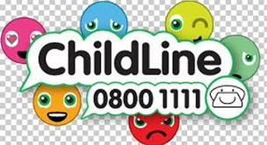

• Information shared between friends can be easily copied and may spread
• It isn’t easy to take back information that has been posted – and can be impossible if it’s already been shared.
• Not everyone your child meets online will be who they say they are. Chatrooms and forums can connect
people who are complete strangers and can be unmoderated
• Chatrooms and forums are one of the places online groomers go to connect with children. They can also be
places where people use a lot of sexual language and engage in online flirting. This is sometimes done through video chat programs.

My child wants to share on social media. Should I be worried?
YouTube (along with other social media platforms) should NOT be used by those under the age of 14 due the associated risks of comments on the videos they post and feedback from viewers which may not always be positive or appropriate.
As with all social media platforms, remind children that what they post online might stay around for a long time and be hard to remove and to bear in mind that embarrassing or controversial content might cause unnecessary stress or impact on education or job opportunities later in life.

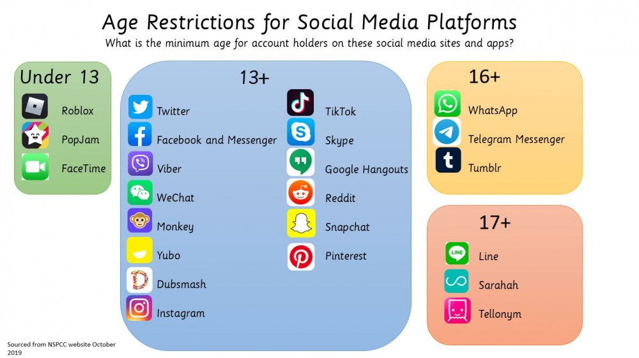

Minecradft is a game that lets you build and create a virual world. This game has chat and server options that can pose a potential risk.

Roblox lets you create your own games or play games that others have made. This game has chat and server options that can pose a potential risk.

Instagram is social network platform that is a popular picture and video sharing app. This app has the fucntion to add people and to chat privately.

Tictok is a social medai platform that lets you create, share and discover vidoes. This platform allows you to add people and to chat. There are many concerns about the risk to children using this app.

Snapchat is a social network app that lets you send photos, short videos or messages to friends. Again this app allows you to add and share and chat with people. There is an instant feature that means what you send disappears when viewed.
Facebook is a social network app which lets you connect with others and share things like comments, photos and videos on your profile. This app allows you to add and share and chat with people.

Grand theft auto is a game where you explore fictional cities and commit crimes, including violence. This game allows chatting and interacting. It has highly adult content.

Whatsapp is a social communication app which lets you send messages, images and videos. There is an instant feature that means what you send disappears when viewed.

