Weston Ferderation Home Learning Overview: Spring 2
Year: 2 | Class: Christopher Columbus, Rosalind Franklin and Stephen Hawking | Date: Tuesday 20th February.
Reading
This half term, we would like your child to read four times per week. We ask that the children are listened to by an adult or older sibling and that this is recorded in their school Reading Record; the purple book. It is important that this is then signed to show they have read - the date, the title of the book and a signature. If you would like to add a comment about your child’s reading you are more than welcome to do so. Adults in school will keep track of the number of reads and children will be rewarded reading badges for the number of reads they complete: Please note that should your child read more than once in one evening, we count this still as one read only- as you can appreciate some children in the past have tried to get twenty reads in one sitting! Short bursts with rich book talk is far more valuable in ensuring reading progress. We understand that reading at home is not always possible. Please inform your class teacher and we can ensure additional reads are put in place.

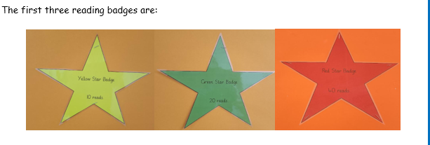
Here are some topic related books you may like to explore at home that link with our Science learning about plants:
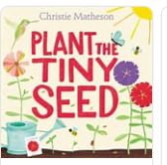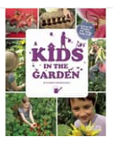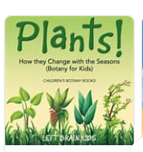

Spellings
The children will continue to learn spellings each week in class. Spellings will be assessed through investigation and practical learning and applied in their writing throughout the half term. Children will bring home spelling homework on a Friday to practise and are invited to return this to school on completion. There will be weekly spelling quizzes every Friday. Here is a list of some of the Year 2 Common Exception words that will be learnt across the year:
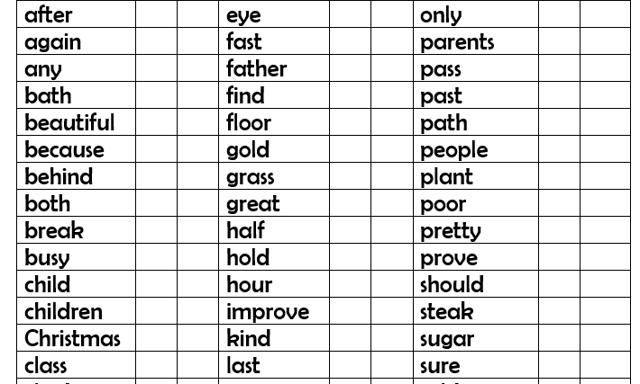

Mental Maths:
This half term we would like your child to practise making amounts with coins. Challenge the to help you add up items when shopping and ask them to locate the correct coins to make the amount. You may find it helpful to start with coin recognition; look at the value of each coin, how many 10ps make this amount? How many 5ps make this amount?

Times tables – this half term children will have times tables quizzes – these will happen on a Friday. The times tables we will be focusing on are: 10s 2s 5s. Quizzes will be done out of order so please challenge your child to recall in different orders, eg 5 x 2 = 8 x 2 =
.
Home Learning creative Project :
This half we are focusing on plants. We will be growing a range of different plants, discussing the different types of seeds and bulbs and looking at all the different plants we eat. We will also be using plants as a focus for our art work. We will be using our sketching and shading skills with pencils, chalk pastels and oil pastels. Please encourage your child to get creative at home and do some fantastic art work around the idea of plants. It could a collage, painting, drawing, printing or some junk modelling. We look forward to seeing your creations.

Hot Topic:
This week we celebrated diversity by taking part in an International Culture Day. We would like you to consider the following statement:
A life without diversity would be…..

