

Weston Federation

Designated Safeguarding Lead is Nicki Windle

Contact on 02380448962

[n.windle@weston-park.org.uk](mailto:n.windle@weston-park.org.uk)

**Key Reminders:**

The weather is remaining cold and damp. Please make sure your child has the appropriate clothing for the weather to enable them to play outside safely.

**Hello and welcome to our monthly safeguarding newsletter / update.**

**If there is any aspect of safeguarding and staying safe you would like us to share please let one of the team know.** September 2022

Dear Sir / Madam,

**RE: Lottie Dale, 21.05.2014, Flat 55, Hampton Tower, International Way, Southampton, Hampshire, SO19 9PB**

I am writing, in response to a request for further information in respect of an application for Disability Living Allowance (DLA) for the above child.

I can confirm that the above child is on the school SEND register and is a child who has a profile of need that requires additional support in school. Lottie has a working diagnosis of ADHD and is also being considered for ASD traits. Many of her needs relate to this diagnosis of ADHD.

Lottie can struggle to read situations appropriately and she has a very fixed view of how things are and should be – she often needs support to explain herself in this regard.

When in school she benefits from a visual schedule / timetable, and she needs support to focus and remain on task. She benefits from the use of a wobble cushion to support her remaining seated, still, and focused. Lottie needs visual supports and reminders to organise herself. She needs a consistent routine; this helps her keep her anxiety lowered so she is able to access the routines and expectations of school. Lottie does not respond well to change and needs time to adapt and adjust to any changes.

Lottie has a range of sensory needs that need additional support in school. She does not like noise or busy spaces despite being very active and noisy herself. She uses ear defenders in school and at home to support with this. Lottie also uses ‘chewlerey’ and is very orally seeking with her sensory needs – she will chew everything and anything so having a sensory aid for this is beneficial. Lottie will chew clothing, hair etc without this.

Lottie also has a range of physical needs – this is centred around her proprioception – she has an occupational therapy program we support her in completing in school, at least twice a week. She is also working on her balance and core stability within this. Lottie also in-toes, this has become more and more pronounced over the last year and has resulted in physiotherapy input daily. Lottie has to complete a range of leg strengthening and positioning exercises at least 3 times daily – we do these in school too.

Lottie is a very energetic and impulsive little girl, she needs careful support and supervision to ensure she is focused and making safe choices – this is especially true when she is out in the community. We know that Lottie often masks her anxiety in school and that when she gets home this is released making her lose regulation and be very unsafe for herself and others – Lottie will lash out and will often try to hurt herself – this needs careful support. To support Lottie with her anxiety, feelings, and emotions she has regular time each day with the SENCO / pastoral support as well as at least weekly ELSA sessions. This has been a feature for some time. With this support we have been able to support Lottie to begin to share her feelings better in school to try and minimise the impact of this at home.

Lottie’s needs have been a feature since she started school in Year R and have become more apparent as she has transitioned through school. Lottie is about to go into year 4, it is our professional opinion that Lottie’s needs will be a long-term feature for her and she will continue to demonstrate a higher level of need.

Lottie’s mum, as a single parent is working with Early Help support to around Lottie’s needs and the challenges these can pose and in how to support them – Lottie needs a high level of support at home too.

If I can be of any further assistance, please do not hesitate to contact me on 02380 448962.

Kind Regards

Miss Nicki Windle

Assistant Head Teacher / SENCO / Lead DSL

**Online Safety**

In these ongoing unprecedented times we are seeing our children and young people spending more and more time online. The raft of apps and games that they have available is vast and ever changing. Here we provide a summary of some of the most popular ones – detailing the risks and guidance associated with them as well as general guidance about social networking.

Please look at the following link for more detail about ALL apps and games –

<https://nationalonlinesafety.com/guides>

Other useful internet safety advice sites are

[www.net-aware.org,uk](http://www.net-aware.org,uk)

[www.internetmatters.org](http://www.internetmatters.org)

[www.thinkyouknow.co.uk](http://www.thinkyouknow.co.uk)

**What age can my child start social networking?**

As a parent/carer it’s important you know that all social networking platforms (apps) have age limits. Some social networks use technologies that mightn’t be right for some ages, or engage with communities that are made up of people much older than your child.

**What are the risks of an underage social networking account?**

• Many sites include an instant message function which allows private conversations

• Most social networking sites have an app version, meaning your child will have access to the social network from their smartphone/tablet. Some app versions of social networks use the location of the phone.

• Information shared between friends can be easily copied and may spread

• It isn’t easy to take back information that has been posted – and can be impossible if it’s already been shared.

• Not everyone your child meets online will be who they say they are. Chatrooms and forums can connect

people who are complete strangers and can be unmoderated

• Chatrooms and forums are one of the places online groomers go to connect with children. They can also be

places where people use a lot of sexual language and engage in online flirting. This is sometimes done through video chat programs.

**My child wants to share on social media. Should I be worried?**

YouTube (along with other social media platforms) should NOT be used by those under the age of 14 due the associated risks of comments on the videos they post and feedback from viewers which may not always be positive or appropriate.

As with all social media platforms, remind children that what they post online might stay around for a long time and be hard to remove and to bear in mind that embarrassing or controversial content might cause unnecessary stress or impact on education or job opportunities later in life.



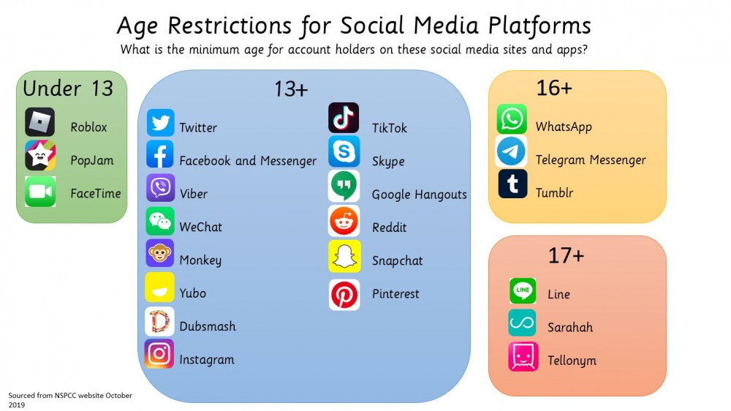

Minecradft is a game that lets you build and create a virual world. This game has chat and server options that can pose a potential risk.



Roblox lets you create your own games or play games that others have made. This game has chat and server options that can pose a potential risk.



Instagram is social network platform that is a popular picture and video sharing app. This app has the fucntion to add people and to chat privately.

Tictok is a social medai platform that lets you create, share and discover vidoes. This platform allows you to add people and to chat. There are many concerns about the risk to children using this app.

Snapchat is a social network app that lets you send photos, short videos or messages to friends. Again this app allows you to add and share and chat with people. There is an instant feature that means what you send disappears when viewed.



Facebook is a social network app which lets you connect with others and share things like comments, photos and videos on your profile. This app allows you to add and share and chat with people.

Grand theft auto is a game where you explore fictional cities and commit crimes, including violence. This game allows chatting and interacting. It has highly adult content.

Whatsapp is a social communication app which lets you send messages, images and videos. There is an instant feature that means what you send disappears when viewed.