Weston Federation Schools
Designated Safeguarding Lead is Nicki Windle
Contact on 02380448962
n.windle@weston-park.org.uk

Hello and welcome to our monthly safeguarding newsletter / update.
If there is any aspect of safeguarding and staying safe you would like us to share please let one of the team know.

This newsletter will focus on 2 themes – Young Carers and Transition / Moving On

Young Carers

At the Weston Federation Schools, we are aware that some of our pupils are young carers – children under 18 who are caring unpaid for a family member or friend who is ill, frail, disabled or has mental health or addiction problems; or helping out with younger siblings in a caring capacity.

Young carers are a potentially vulnerable and disadvantaged group who frequently experience difficulties in their education as a result of their caring role.

We are keen to ensure that we are identifying all our young people who may fit the criteria of being a young carer.

As part of the Young Carers in Schools programme, a national initiative to equip schools and award effective practice with the support of the Carers Trust and The Children’s Society – the Weston Federation Schools are committed to supporting young carers and have signed up to the Young Carers in Schools programme (launching September 2022).

We are working towards the Young Carers in school award.

Our federation of schools has appointed a Young Carers’ School Operational Lead who will carry out a baseline review of the school’s current provision for

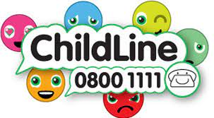

young carers and their families. The lead for this is Nicki Windle supported by Kerry Taylorson.

Children in school recently took part in workshops about being a young carer and what support is available for anyone in this category as well as what to do if they feel they are a young carer.

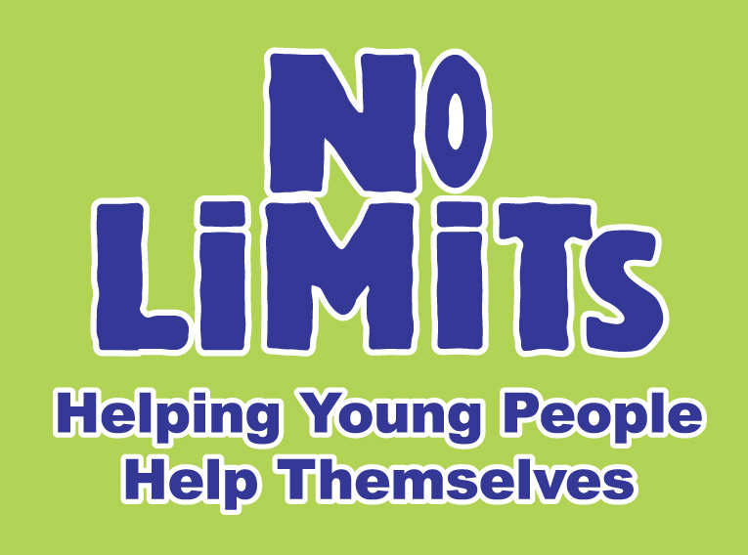

No Limits in Southampton lead the support for Young Carers across the city.

For Young Carers in Southampton, they offer the following –

- Youth Support Group – Face to Face​

- 1:1 support – in school, in the community or online​

- Workshops – such as - What is a Young Carer?, Looking After Myself, Autism, What is Cancer​

- Fun Activities and Day Trips throughout the year​

- Residentials including the annual Young Carers Festival Weekend

- Young Carers Champions – Local and National Platform

We know that many of our young people have caring responsibilities, if you feel this could be your child please arrange to speak to Nicki Windle / Kerry Taylorson so the relevant referral and support can be arranged. There is a lot of support we can access for our young People who are carers so please do come forward and speak to us.

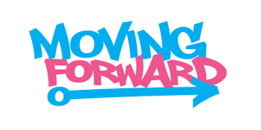

This week the children will get to ‘move up’ to their next class and to meet their new class teachers. For the vast majority of our children this is an exciting time – they will hopefully come home full of excitement about the year head after their transition morning on the 6th July.

We are aware however that there are some children who may have some worries connected to this or that may be anxious about change.

We have been focusing, in school on the skills needed to manage transition and to support anxiety about change.

The children have had the opportunity to take part in these sessions in the build up to transitions.

We recognise that for some of our children a more personalised plana and approach is needed. Many of these plans have discretely started and will be more explicit following transition morning. This can include extra time with their new teaching team, additional visits to their new year group / glass, social stories and more. If you feel that this is something your child may benefit from please speak to their current class teacher or contact Nicki Windle the federation schools’ SENCO.
To support you in helping your child with transition we have the following tips / hints to help =

Change is a normal part of life and can provide opportunities for children and young people to develop their resilience.

- Talk to them about their concerns – try not to share any of your own worries or concerns as this can increase theirs
- Look back and share examples of when they have managed change before and how this can be a good thing
- Focus on the positives
- Talk to the appropriate person at school if extra support is needed
- Spend time with your child, talking, playing / drawing together and gently discuss the changes coming up and help them see the positives as well as their worries
- Reassure them – some things are changing, and some things are staying the same and this is ok
- Stay calm and be consistent
- Prepare them, over the summer remind them of their new teacher, class, school and so on so they are prepared – talk about it
