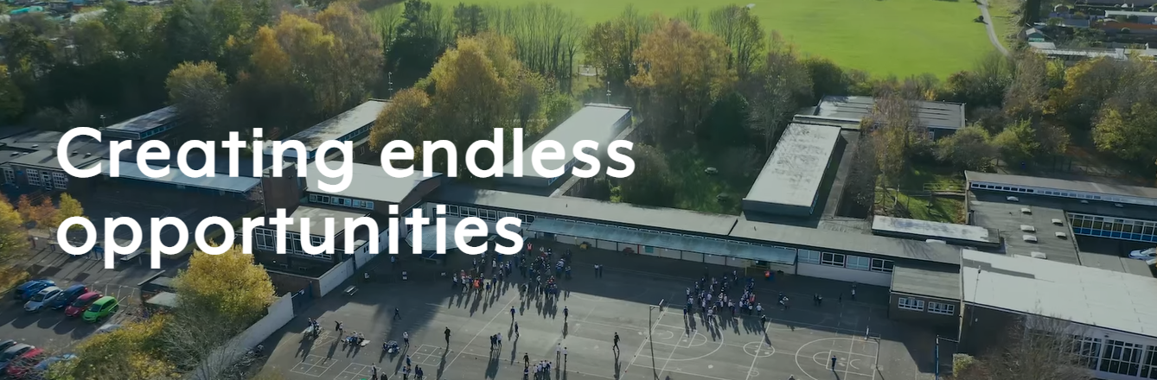

**Weston Federation Newsletter**

**Summer Term**

**Key dates**

Tuesday 11th June – Year R Longdown

Tuesday 25th June – Year 2 Sea City Trip

Tuesday 25th June – Year R Sports Day (AM)

Wednesday 26th June – Year 1 & 2 Sports Day (AM) Years 3 & 4 Sports Day (PM)

Thursday 27th June – Year 5 & 6 Sports Day (PM)

Tuesday 9th July – Year 6 Paultons Park

Wednesday 24th July – Last Day of Summer Term

Summer Holidays – Thursday 25th July -Wednesday 4th September

**Message from Mr Wiltshire**

Dear Parents and Carers at Weston Park and Weston Shore,

Today we are really looking forward to Run, Weston, Run. An event for our outstanding runners. We can't wait to give them the stage they deserve to perform.

As you may know, this follows an art competition against other schools and a Times Tables Rockstars one too. At each of these the children have been an absolute credit to themselves, their families and our schools. We are so proud of them for having such a positive mentality and for being so skilled.

In July we look forward to The Olympics! Many of our events are in connection with our commitment to living healthy lives. Healthy eating, exercise and consistent sleep routines.

As half term is once again here, we wish you a peaceful break and we look forward to seeing the children back in school on Monday 3rd June.

Mr. Wiltshire,

Executive Headteacher Weston Park and Weston Shore.



**This term in Key Stage One**

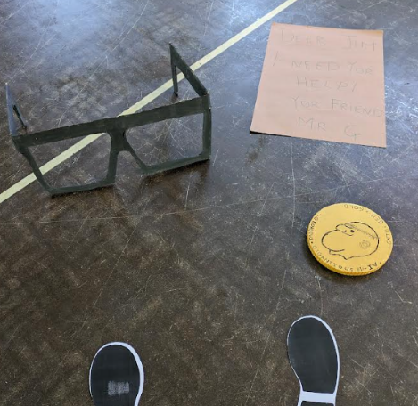

Year 1 have had a fantastic Summer 1. Our enquiry question has been 'How can we take responsibility for our environment?" and in English we wrote persuasive letters to Mr Wiltshire advising him on how we can look after our school and our local area. We also had an exciting visitor to our school in the form of a giant. It turns out that he needed our help to help him get himself back on his feet again and feeling better. We were so excited to find the letter he had left us and some of his giant belongings that he left in the school hall! It has been a busy half term, and we are very much looking forward to our final half term in Year 1!

**Reception**

Year R had an exciting start to the summer term with the discovery of mystery eggs in the garden. We were delighted to find two baby dragons hatched a few days later and we have been busy teaching them all the things that dragons need to know. The children have been exploring using their imagination through art and drama as well as writing about their ideas in Drawing Club! We are so impressed with the progress they have made with their independent work, particularly in reading and writing.

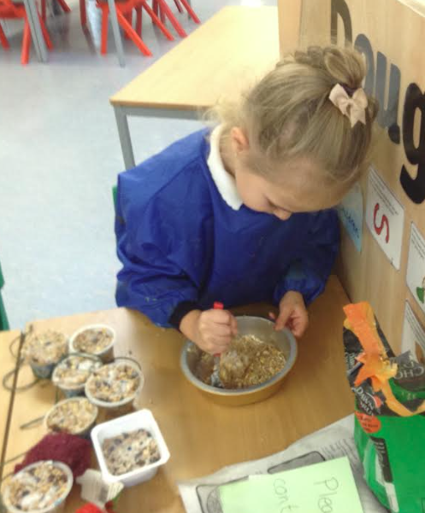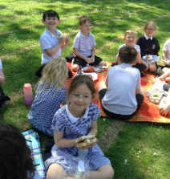

**Year 2**

This half term has been action packed with learning for our Year 2 classes. We have been developing our reading comprehension skills across a range of text types. The children have thoroughly enjoyed being historians, enquiring about the events leading up to the sinking of the Titanic and comparing the reliability of sources. In Design Technology we designed and made healthy sandwiches which we enjoyed as part of an outside picnic.



**This term in Key Stage Two**

**Year 4**

This half term, Year 4 have enjoyed learning about the Ancient Mayans in history and creating Mayan headdresses within DT. They have also enjoyed reading the book Rainplayer and creating a newspaper report on the Pok-a-tok game within the story.

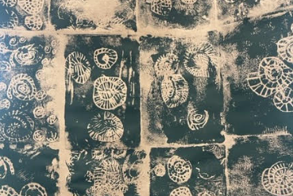

**Year 3**

Another half term has flown by and what a half term it has been! The children have loved learning about the Iron age and what life was like. In science the children have learned all about how to grow their own plants and what is needed to a keep a plant alive.

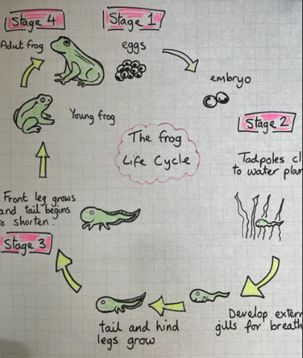

**Year 5**

Year 5 have had a fantastic half term working hard across all areas of the curriculum. In science the children have been learning all about the life cycles – they particularly enjoyed learning about the life cycle of a frog.

**Year 6**

After a very busy half term and working so hard to smash our SATs, Year 6 designed and made cushions using scraps of old material in our make do and mend unit. This linked to our on-going World War Two unit which the children really immersed themselves in.

**Community news**

**Coffee Mornings**

**Following the success of our two NVR courses we will be continuing our catch-up coffee mornings throughout the autumn term**

**Join Danny, member of the mental health team, the ladies from NVR, Mrs Windle and Mrs Hamilton in the Reema building on a Monday morning straight from drop off.**

**Wake up Wednesdays**

**Understanding online safety is tricky for all ages, so we have joined forces with the Wake Up Wednesday campaign to keep you updated with tips and tricks for keeping you children safe whilst online. So every Wednesday keep an out eye on our Website and social media pages for the latest online safety advice.**

**Weston CIA**

**A big thank you for all that continue to support Weston CIA – keep an eye out for events happening in the summer term.**

**Food banks / other help**

**We know times are tough and we are here to help, where we can. Please come and talk to us if you need access to a food bank or other welfare support, we know it can be hard but we are here to help.**



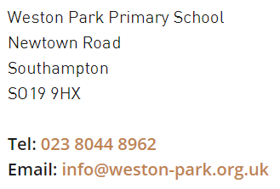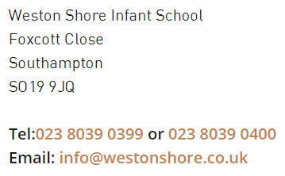

**Contact us on**