Weston Park Primary School
Designated Safeguarding Lead is Nicki Windle
Contact on 02380448962
n.windle@weston-park.org.uk

Hello and welcome to our monthly safeguarding newsletter / update.
If there is any aspect of safeguarding and staying safe you would like us to share please let one of the team know.

Water Safety?
As we have started to see some warmer weather and signs of spring, we are focusing this safeguarding newsletter on water safety.
We have a fantastic resource of Weston Shore right on our doorstep – as lovely as this is there are dangers associated with the ‘beach’ and water.

What to look out for on the beach
Signs
When you arrive at the beach the first thing you might see is a sign giving you all the information about the beach you’re visiting. This includes important safety info on the hazards specific to the area. The signs generally use two different types of warning symbols. Do you know the difference?
Red and white prohibition sign - Do not enter the water at any time. Swimming and other water-related activities are not permitted.
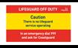
No lifeguards sign - There is currently no lifeguard service at this beach. You should exercise caution and follow all safety advice to protect you and your family.

Flags

If the beach you’re at is not lifeguarded, please take extra care if you are going into the water. If lifeguards are on patrol, then you’ll need to know your flags:

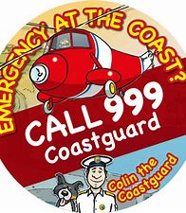

Red and yellow beach flag - Lifeguarded area. Safest area to swim, bodyboard and use inflatables.

Black and white chequered beach flag - For surfboards, stand-up paddleboards, kayaks and other non-powered craft. Launch and recovery area for kitesurfers and windsurfers. Never swim or bodyboard here.

Red beach flag - Danger! Never go in the water under any circumstances when the red flag is flying.

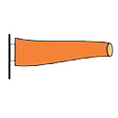
Orange windsock - Indicates offshore or strong wind conditions. Never use inflatables when the windsock is flying.

Understand the Sea

Tides / Currents
Rip Currents are strong currents running out to sea, which can take you quickly out of your depth.

If you get caught in a rip current:
- Keep calm. Don’t fight the rip current.
- To get out of the rip current, swim sideways, parallel to the beach. This will get you out of the rip current so you can swim back in with the waves helping you along.
- When out of the rip current, swim at an angle away from the rip current and toward shore.
- If you can’t escape this way, try to float or calmly tread water. Rip current strength eventually weakens offshore. When it does,swim away from the rip current toward shore.
- If at any time you are unable to reach the shore, draw attention to yourself: face the shore, wave your arms, and yell for help.

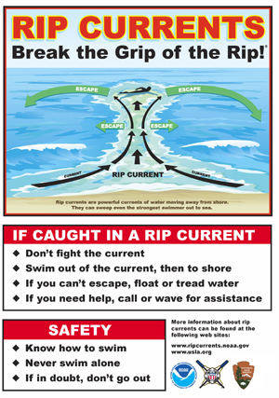

A beach can seem like a good place to play but the tide can come in surprisingly quickly, making you can get cut off from land very quicjkly and with little warning.

Because tide times and heights vary throughout the month, a beach that was clear yesterday at 5pm might be completely covered in sea at the same time today.
Spring tides have greater depth range between high and low water, so at high tide the water comes in further up the beach.

Coffee Mornings / NRV
Our coffee mornings continue on a Monday morning in the Reema block. We have our NVR and parent supporters there to welcome you in a safe welcoming environment. All are welcome. Do come and join us for a tea / coffee and cake.
Our NVR (New View of Relationships) course runs every Wednesday morning in the Reema block.
Look out for more parent events coming soon.
Waves
Waves are great fun, but they can be dangerous. They have different characteristics depending on the beach and conditions - understanding how they work will keep you safer.

Spilling waves - Spilling waves are softer and more consistent waves that break gradually as they approach the shore. They are ideal for beginner board riders. Start off in the shallow white water before you progress to deeper water and unbroken waves.
Dumping waves - Dumping waves break powerfully in shallow water and should be avoided. They most commonly occur at low tide and break quickly with a lot of force making them dangerous for beginners.
Surging waves - When a wave breaks it loses some of its power and momentum. Watch out for surging waves - they don’t break, so they can knock you off of your feet more easily and drag you into deeper water.

If you get into difficulty, call 999 for the coast guard and if in water, whilst waiting for help - float to live

How to Float to Live

- Fight your instinct to thrash around
- Lean back, extend your arms and legs- think Starfish
- If you need to, gently move them around to help you float
- Float until you can control your breathing
- Only then call for help or swim to safety

Useful Websites about Water Safety

Water Safety Advice And Tips - Know The Risks (rnli.org)

