Building Bridges: A Remarkable Visit to China by British Educators
Our story began with a partnership that felt less like an agreement and more like a shared dream. The Confucius Institute at the University of Southampton opened a door to a world where our pupils could see beyond the horizon of their own streets. Through this collaboration, our children discovered that learning is not confined to classrooms; it is a bridge that connects lives, cultures, and hopes. The Institute’s unwavering commitment to fostering understanding between nations has been the heartbeat of this life-changing journey, a journey that would not have been possible without the generous support of CIEF (China International Education Foundation), for which we are deeply grateful.
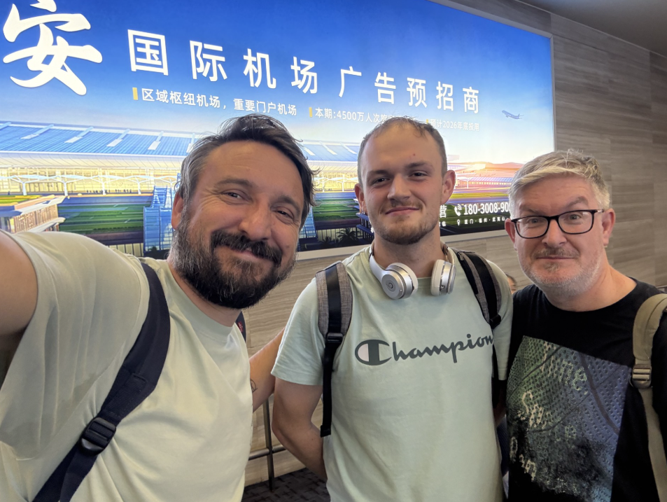
In late October 2025, together with Mr Farr and Mr Reid, I had the privilege of representing British education on a cultural and professional visit hosted by Xiamen University through the prestigious Chinese Bridge programme. From the moment we arrived, we were embraced with warmth and generosity. The welcome ceremony at Xiamen University’s Siming Campus was elegant yet deeply personal, setting the tone for a journey filled with learning and heartfelt encounters. The university’s beautiful grounds and rich academic heritage left a lasting impression on us all.
Our visits to local schools, including Yanwu Primary School, Wuyuan Second Experimental School, the Haicang District Teacher Training School Affiliated School, and Zhongtang Experimental School of Beijing, were deeply moving. Instantly, we were struck by the dedication of the educators, the enthusiasm of the students, and the innovative approaches to teaching and learning. These schools were not only centres of academic excellence but also vibrant communities that celebrated culture and creativity.
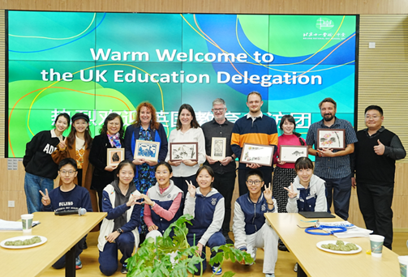
At Zhongtang Experimental School, I experienced a moment that will stay with me forever. A student stood clutching her notes, eager to share a story about the school’s farm. Her eyes shone with anticipation, but time was unkind, an exam called her away before she had her chance to speak. Seeing her disappointment, I suggested to the headteacher that she record her story, which she had clearly worked so hard to prepare, and send it to me in England. I promised to respond with my thoughts and share it with my students back home. There may have been a language barrier, yet it was unmistakable how happy she was with this simple gesture. In that moment, she knew her hard work would still be valued. That fleeting moment reminded me why we are educators: because we want the very best for every child, no matter where they are in the world, and we must do the best we can to make that happen.
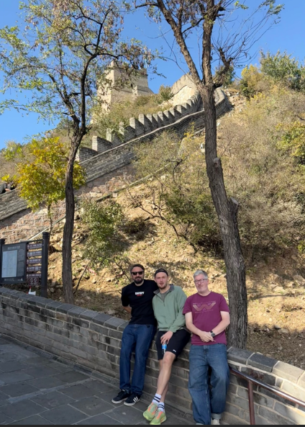
The cultural experiences woven into our itinerary were nothing short of breathtaking. From the architectural wonders of Gulangyu Islet to the historic grandeur of Tian’anmen Square, the Forbidden City, and the Great Wall, we were immersed in the rich tapestry of Chinese history and tradition. Each moment deepened our appreciation for the country’s heritage and its people. I wandered through the beauty of Gulangyu Islet, stood in awe at Tian’anmen Square, and traced the ancient stones of the Great Wall with reverent hands. Each step was a heartbeat, each sight a memory etched in gratitude. But these experiences were more than cultural, they were reminders of why I teach. Standing before monuments that have endured for centuries, I felt like a child again, filled with awe and wonder at a new world. It reminded me of my duty as an educator: to give children the chance to see beyond the walls of their classrooms, to open doors to worlds they may never have imagined. Education is not just about knowledge; it is about shaping lives, nurturing curiosity, and building bridges of understanding that span continents. This journey reaffirmed that when we invest in cultural exchange, we invest in a future where empathy and friendship outshine fear and distance.
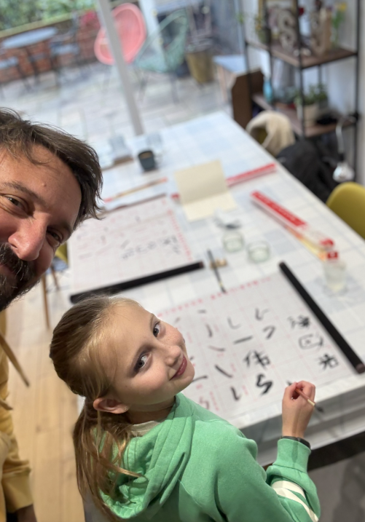
I was humbled and deeply honoured when Professor Su gave Chinese names to me and my family, a gesture that felt like weaving our lives into the fabric of this beautiful culture and the friendships we had formed. It was more than a name; it was a bond, a promise that these connections would endure. To honour this gift, I gathered brushes, ink, paper, and notebooks to take home, so we could practise writing our new Chinese names together. I imagined evenings around the table with my family, learning the art of calligraphy. Each brushstroke would not only echo centuries of tradition but also speak of gratitude, respect, and the friendships that now link our hearts across continents. These were not souvenirs; they were symbols of respect, gratitude, and bonds that will endure long after the journey ends.
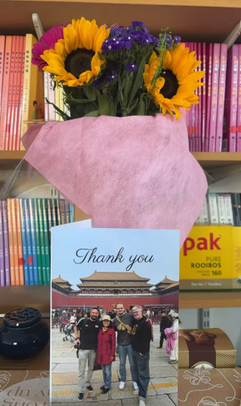
After our unbelievable journey, one that was truly life-changing and filled with new friendships, we felt compelled to send a small gift to Professor Su as a token of our appreciation and the bond we had formed. This simple bouquet carried a world of gratitude to Professor Su, the CIEF, Xiamen University, and all those who made this journey possible. These gestures, small yet profound, are the true essence of building bridges. They remind me that kindness travels farther than any plane ticket.
Throughout the visit, one theme resonated deeply: the power of building bridges. We left China not just with lifelong memories, but with a renewed commitment to creating meaningful partnerships between our schools and those in China. Cultural exchange and collaboration are not luxuries, they are lifelines that prepare our students to become global citizens: curious, respectful, and open to the world.
This was not just a visit. It was a tapestry of laughter, learning, and appreciation, a story of cultures meeting not as strangers, but as friends. I returned home with a heart full and a promise burning bright: to keep these bridges strong, to let our children, my own children, walk across them into a future where curiosity conquers fear and friendship outshines distance.

David Osborne, 岱伟

