Weston Schools Federation Home Learning Overview: Spring 1
Year: 1 | Class: 1S 1R 1J | Date: 5th January to 13th February
Reading

At school, children read their book three times with an adult in class and then that same book goes home for further practice. Children should be confident and fluent with reading it by the Friday. Parents can then record the reading their child does at home on the Boomreader app. We recommend reading at least 3 times per week.

Teachers will then look at the app to see how many reads have been recorded so that reading badges can be awarded. The number of reads for each badge has not changed and is detailed below.

Yellow – 10 reads
Green – 20 reads
Red – 40 reads
Blue – 60 reads

Silver – 80 reads
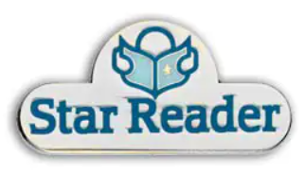
Gold – 100 reads
Star reader – 150 reads
Bronze bookworm – 200 reads
Silver bookworm – 250 reads
Gold bookworm – 300 reads

Reading and spelling of tricky words
Children will soon be coming home with tricky words to practice. These words are tricky because they cannot be sounded out in the usual way; the words have a part that is tricky because it doesn’t follow the usual phonic rules. We recommend focussing on 4 words at a time so that your child does not go overwhelmed and can quickly feel successful.

Play ‘win it’.

- Choose 4 words. It’s a good idea to pick 3 they know quite well, and 1 that they are not sure of.
- Say the 3 familiar words to your child.
- Get your child to repeat the words with you.
- Introduce the new word. Say it lots of times with your child.
- Add the new word to the pack of other cards.
- Show each card in turn. Can they put their hands on their head when they spot the new one? Can they say the word? Repeat a few times. When they become confident with the new word, try a different word the next day.

Here is a list of tricky words. Children have been introduced to Phase 2, 3 and 4 and have just started Phase 5.

Phase2 |  | Phase 3 |  | Phase 4 |  | Phase 5
is  I  the  put  pull  full  as  and  has  his  her | go  no  to  into  she  push  he  of  we  me  be | was  you  they  my  by | all  are  sure  pure | said  so  have  like  some  come  love  do  were | here  little  says  there  when  what  one  out  today | their  people  oh  your  Mr  Mrs  Ms  ask  could  would  should  our  house  mouse  water  want  any  many  again  who  whole | where  two  school  call  different  thought  through  friend  work  once  laugh  because  eye  busy  beautiful  pretty  hour  more  improve  parents  shoe

Maths
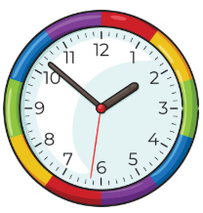
In Maths we have been learning about telling the time. We have taught children to read and make the times “o’clock” and “half past”.

Here is a fun game to explore online:

https://ictgames.com/mobilePage/hickoryDickory/index.html

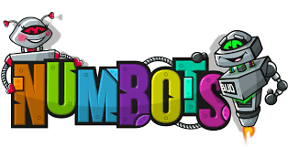
Numbots

Please continue to motivate your child to access Numbots and support them in completing games and levels. Effort on Numbots is rewarded with certificates each week. Please ask your child’s teacher if you need log in details.

Home Learning Project

This term in Science we are learning about animals. We will learn about the different classification groups – birds, reptiles, amphibians, mammals and fish. We will also explore the features and needs of herbivores, carnivores and omnivores.

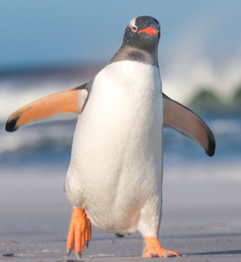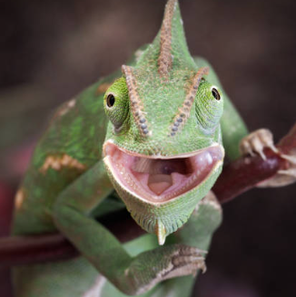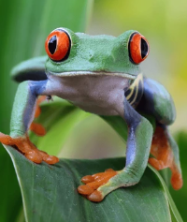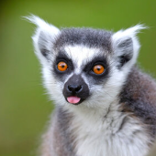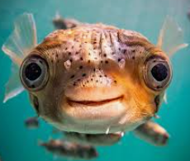

What is your child’s favourite animal? We would love to hear all about it! You could use the internet or visit one of our brilliant local libraries to find out more. Your research can be presented as a poster or mini booklet that your child can share in class. Please bring in any projects by Friday 13th February.

