Weston Park Home Learning Overview: Autumn 2
Year: 3 | Class: 3D, 3R, 3TJ | Date: 24.2.26 – 23.3.26
Reading

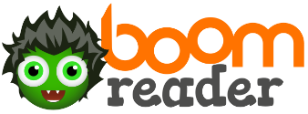

This half term, we would like your child to read at five times per week at home to improve their fluency. We ask that the children read for at least 20 minutes and are listened to by an adult or older sibling at least once a week. Each time they read, and you observe this happening, please ensure you add it to Boomreader. We have some children who are racing through their reading badges and it would be great to have even more!

They should read their Home accelerated reader book. All the children have been given a Home accelerated reader book to read at home. All children have also been given their boom reader details. If you need the details again, please speak to your child’s class teacher. We ask that you speak to them about what they have read, examples of questions could be:
Why do you think (character) did that? How do you know how (character) felt? What words could you use in your writing? Can you find a synonym (word that means the same) as _____? What do you like about the book? Why? You could even encourage your child to ask their own questions to get them thinking about the book. Try asking your child to summarise what they have read in one sentence.

We are checking Boomreader daily and are rewarding the children who read regularly for their effort.
Spellings
Spellings are sent home weekly and are comprised of six spellings following a certain pattern that the children are learning, plus two words from the Year 3 / 4 common exception words list below. On a Friday, the children’s spelling test has two additional words from the Year 2 common exception words list to check that children are still remembering these spellings as well.
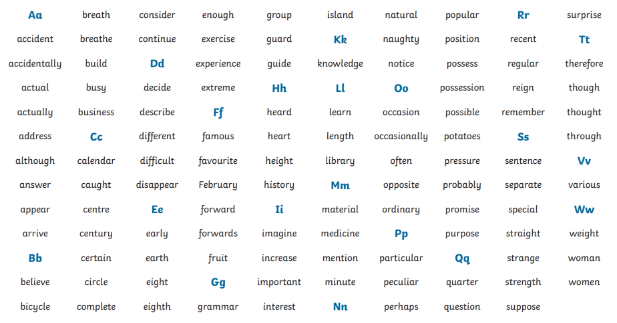

Times Tables
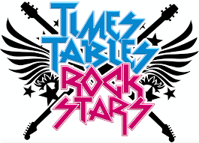
Many Year 3 children have been doing a fantastic job of their times tables this year, regularly practising and helping their classes win the monthly Year 3 tournaments set up by Mr Reid. These tournaments count the points from the first ten minutes that children spend on TTRS each day – therefore, the more children from each class that use TTRS every day, the more chance their class has of winning the monthly tournament!

Where possible, please can we ask that your child has access
to this website and practices at home; either every day or at least 3 times a week. If there are any problems, please speak to your child’s teacher.

Home Learning creative Project
This half term in Year 3 we will be learning about the Stone Age.

We would like children to make a 3D model of a Stone Age village using card, sticks, paints – whatever comes to hand! There are some great ideas online to get you started:

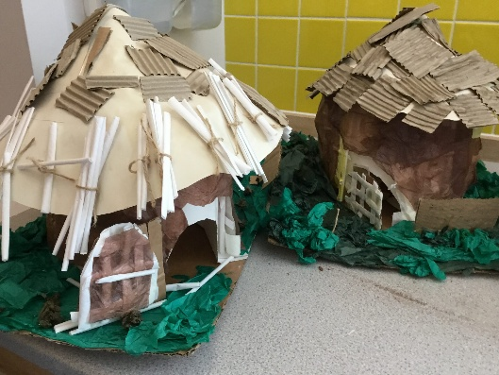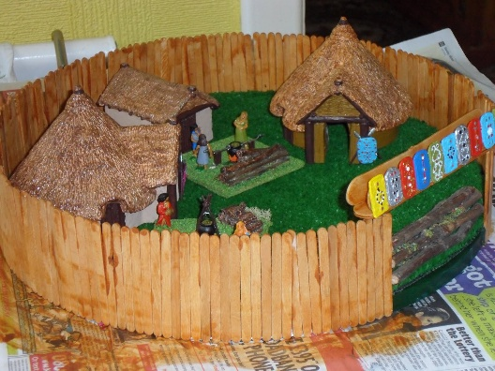

Your deadline is: Friday 23rd March.
Hot Topic to discuss

In our science we will be looking at the science of rocks. You could discuss:

What types of rock are there?
Where do they come from / How are they formed?
How does fossilisation happen?

In PSHE we are talking about respectful relationships. You could talk about:

Who can you talk to when you experience different emotions?
How can people’s body language show their feelings?

