Weston Park Home Learning Overview: Spring Term 1
Year: 4 | Class: 4C, 4K, 4V | Date: January 5th – February 13th
Reading
This half term we would like your child to read at home at least five times per week as we continue to improve reading fluency. This is a vital skill for life. We ask that the children are listened to reading by an adult or older sibling and that this is recorded on boomreader. In order to support the children, please ensure they you log on boomreader whenever they read. They could read their home accelerated reader book or other texts available at home (this could include magazines or newspapers). Each time a boomreader log in submitted, it will go towards their total reads and the children will earn reading stars.

We know that evenings can be busy so your child could read to you or another person while preparing meals, travelling in a car or getting ready for bed. You could sometimes read to your child or use a reading buddy system where you take it turns to read parts of the book and then ask them some questions. We recognise that not all children will want to read aloud every day and ask that instead you speak to them about what they have read, examples of questions could be:

Who is the author? What does the word _____ mean? (Read the words around it to help you figure it out – context),
Who are the main characters? What do you think will happen next? How do you think the character feels? How would you feel in that situation? Is there a hidden message in the story? Would you recommend the book? Would you read a book by the same author again? Do you like how it ended? What would you change about it? Why? If it is a news article – what happened? Where did it happen? What is your opinion? Who does it affect?

Please submit a boomreader reading log daily. Every time your child reads and a boomreader reading log is submitted it will go towards their read star total. If you have any issues logging on to boomreader, please speak with or send a message to the class teacher and they can provide you with login details.

Spellings
Spellings will be assessed through investigation and practical learning and applied in their writing throughout the term. Please support your child in learning these key spellings from the Year 3/4 curriculum. They should be able to read and spell all of these words by the end of the year.
Also there will be weekly spelling tests of 10 words. These will be based on some of the common exception words below. We will share these with you weekly.
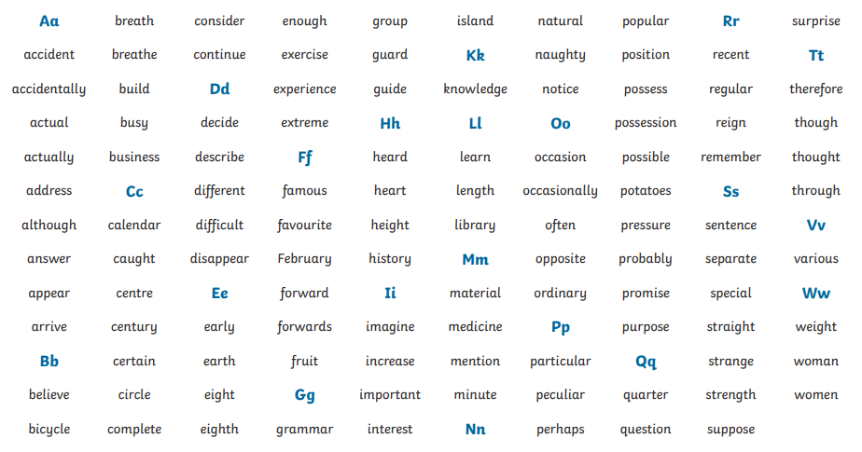
Times Tables

To support your child with their times tables understanding we have subscribed to ‘Times Tables Rock Stars’. This is a fun and engaging times tables based website which has been extremely popular in many schools nationwide.

This year, children will be practice their times table daily leading to a times table assessment at the end of the year. Children will also be using and applying their times tables knowledge in all areas of maths. Learning times tables will improve quick recall and support the children’s arithmetic skills.

Where possible, please can we ask that your child has access
to this website and practices at home; either every day or at least 3 times a week. If there are any problems, please speak to your child’s teacher.

We will continue with times tables testing weekly and this will be covering the 6,7,8,9,11 and 12 times tables.

Home Learning Creative Project:
The home learning project this half term is centred on our topic of rainforests. We would like the children to create a rainforest diorama. You could use an old shoe box or an opened out cereal box as a base, then add in pictures and facts related to rainforests and rainforest animals.

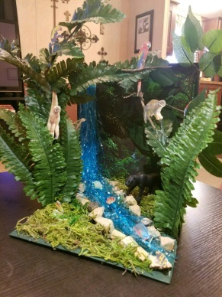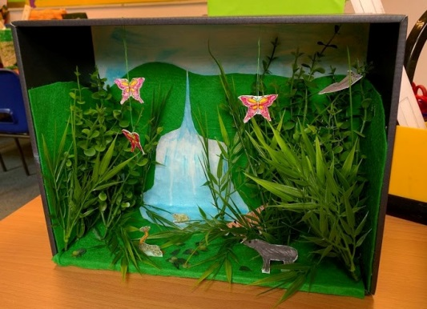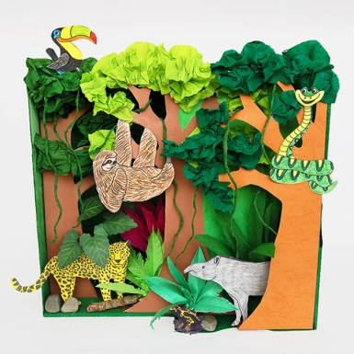

We hope that all of the children will enjoy becoming absorbed in creating some really exciting projects. We will be reminding children that this is a project that will last the whole half-term and that the outcome must show a substantial level of effort. We would expect the same standards of home learning as we do from all other school learning.
Your project is due in by Friday 13th February. Remember to bring in your projects so your class teacher can take pictures of them. These will be celebrated in class and some will be posted on the school’s facebook page to celebrate home learning.

If you have any further questions, please do not hesitate to speak to one of the Year 4 team.

Hot topics to discuss:
Relating to Safety, ask your child…
- How can you keep yourself safe now the evenings are darker?
- How can you keep safe when you travel to and from school now that the mornings and days are darker?
- How can we keep each other safe?

Relating to our whole school theme of resilience….
- Is it equally important for everyone to show resilience?
- What skills do I need to apply when being resilient?
- How will becoming more resilient help you?
- Who can help us develop our resilience?
- What can happen if you become more resilient? How will this feel?

