Weston Park Home Learning Overview: Spring Term 2
Year: 4 | Class: 4C, 4K, 4V | Date: 16th February – 20th March
Reading
This half term we would like your child to read at home at least five times per week as we continue to improve reading fluency. This is a vital skill for life. We ask that the children are listened to reading by an adult or older sibling at least once a week and that this is recorded on our online reading record, Boomreader. In order to support the children, please ensure whenever they have read that you submit an reading record using Boomreader. They could read their home accelerated book or other texts available at home (this could include magazines or newspapers).

We know that evenings can be busy so your child could read to you or another person while preparing meals, travelling in a car or getting ready for bed. You could sometimes read to your child or use a reading buddy system where you take it turns to read parts of the book and then ask them some questions. We recognise that not all children will want to read aloud every day and ask that instead you speak to them about what they have read, examples of questions could be:

Where/when does the story take place? If you were going to interview one of the characters, which questions would you ask and why? Which is the most interesting/exciting/funniest/scariest/your favourite part of the story/play? Why? Tell me about one important event that happened that could not be left out. Say why it was so important. Did any of the characters show their feelings? How/why did they show this/these feeling(s?) What do you think is going to happen next? Why do you think this? Which part of this poem did you like best? Why?

Please submit a reading record onto Boomreader regularly. We will check Boomreader every morning and will issue rewards for those who have their log signed at least 4 times a week. We also want all children in year 4 to have the opportunity to earn reading badges, so if there is not reading record on Boomreader for the week, they will be given a chance to read to an adult in school time, maybe break time or lunchtime to add to their badge total.

Spellings
Spellings will be assessed through investigation and practical learning and applied in their writing throughout the term. Please support your child in learning these key spellings from the Year 3/4 curriculum. They should be able to read and spell all of these words by the end of the year.
Also there will be weekly spelling tests of 10 words. These will be based on some of the common exception words below. We will share these with you weekly.
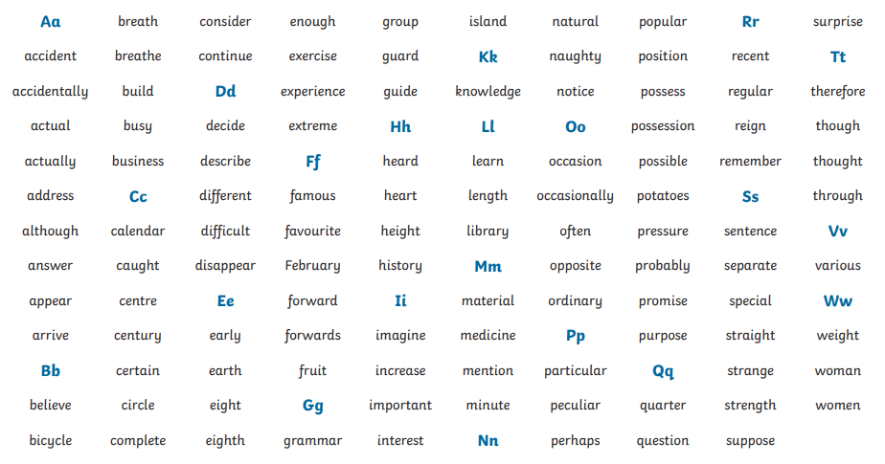
If you feel your child is secure at spelling the majority of these word already, you could explore the suffixes and prefixes within them. What would the impact be if we removed the suffix/prefix. Particularly become particular. The way we would use it in a sentence changes, How?

You could also discuss what happens to the words if we add suffixes and prefixes. Can we do this to all words? What rules have been used to add the suffix.
Times Tables
The children have been using the programme ‘Times Table Rock Stars’ to improve the speed of the times tables recall. Regular practice will really support your child to feel more confident in all areas of maths and also support them in the lead up to the new Year 4 statutory Multiplication Tables Test. The programmes are monitored by the teachers and certificates will be issued for speed and knowledge progress. We will be recording the stats each week for accuracy, speed and percentage of children logged on per class, so the more questions children answer correctly, the better their class will do – I’m sure the competition will be fierce! Please remind them to log on!


Home Learning Creative Project:
In Spring 2 we will be continuing our learning about rainforests.
This half term we would like to give a choice of project (or you could do both).

- A presentation on deforestation responding to our key questions:

Do rainforests really matter?
Should human need trump animal rights?

Although you do not have to stand up and present your work to the class if you do not want to, it would be lovely to hear the children presenting their work in their own words.

Presentations could feature a poster, a non-chronological report, a persuasive piece of writing such as a letter, poem or debate, maps or even a Power Point slide show. If children wish to, they could talk through their project by video or voice recording on seesaw.

Areas to look at could include:
- Causes of deforestation / Why it happens
- The effect on animals
- The effect on humans
- The effect on the environment
- Ways we can help
- Food, glorious food!
Try foods which are natural resources grown in a rainforest. Create some recipes and make some dishes using one or a few of these ingredients. When shopping, look at labels of origin to see what fruit and vegetables may have been grown and shipped in from South America. What do you notice about their price? Why can they not be grown closer to the UK?
Photos and videos of your findings, taste testing and recipes and final dishes can be brought into school for your class teacher and peers to celebrate.

Hot topics to discuss:
Relating to Safety, ask your child…
- How do you stay safe online?
- How can you help others stay safe if they are in a medical or other emergency?
- How can you keep yourself safe in a new or unknown environment?
- What makes someone a ‘trusted adult’?
- What would you do if we got separated or you got lost in a shop?
- How can you help keep the house safe and risk-free?

Relating to our whole school theme of resilience….
- How do you deal with setbacks?
- What could help someone become more resilient?
- What helps motivate you to be resilient?
- If you lose a game, what would help you stay resilient?

Key dates:

