Weston Park Home Learning Overview: Spring 1
Year: 6 | Class: 6G 6P 6L | Date: 5.1.26 – 13.2.26
Booster sessions:
The above are continuing to run this half term. Your child would have received an invite. Please encourage them to attend.
Reading
Boomreader

This half term we would like the children to be reading as much as they can, every night if possible, so they can practise their fluency. With increasing fluency comes increased understanding. When reading at home, please use Boomreader to record reading so that the children can earn their reading badges. To support with preparation for SATS it would be beneficial to ask your child questions about what they have read. Below you will find some inference style questions:
Who is the author? What does the word _____ mean? (Read the words around it to help you figure it out – context),
Who are the main characters? What do you think will happen next? How do you think the character feels? How would you feel in that situation? Is there a hidden message in the story? Would you recommend the book? Would you read a book by the same author again? Do you like how it ended? What would you change about it? Why? If it is a news article – what happened? Where did it happen? What is your opinion? Who does it affect?
Accelerated Reader

All children have an Accelerated Reader Book- AR reading books have a little orange sticker with a number on it on the front. These books are targeted specifically to your child’s reading ability. Children should bring these books home every night to read and ensure they bring them back to school each day. When they have read the book they will carry out a test online to check their comprehension.

Spellings
Spellings will continue to be sent home on a Friday for Look Cover Write Check practice and are tested the following Friday. These spellings are usually linked to our learning in English so knowing them really helps the children to be successful in their independent writing.
Additional Homework:
Children will continue to bring additional homework home – one week Maths, the next Reading. As previously mentioned, this regular routine helps them to prepare for Secondary School where they will be expected to do homework each night. A reminder, if children cannot complete this at home, they have the option of completing this on a Tuesday lunchtime. Any children who do not hand their homework in on a Friday will be asked to complete it during lunch.

Mental Maths:
We have now relaunched TTRS and will be giving out weekly certificates for the most engagement at home. If you need a reminder of your child’s login, please do ask. Watch this space for details about an upcoming TTRS dress up day on the first day back after the Christmas break.

The additional Maths homework will support your child in developing their arithmetic skills; accuracy and efficiency so it’s vital they complete this. If your child would like any additional practice please speak to your class teacher. We will continue to carry out weekly arithmetic tests and share the scores with your child each week.
Additional Projects:

Research: To research the significance of famous scientists.
This half term we will be learning about Carl Linnaeus and the contributions he has made to Science. We will focus specifically on the use of classification keys.
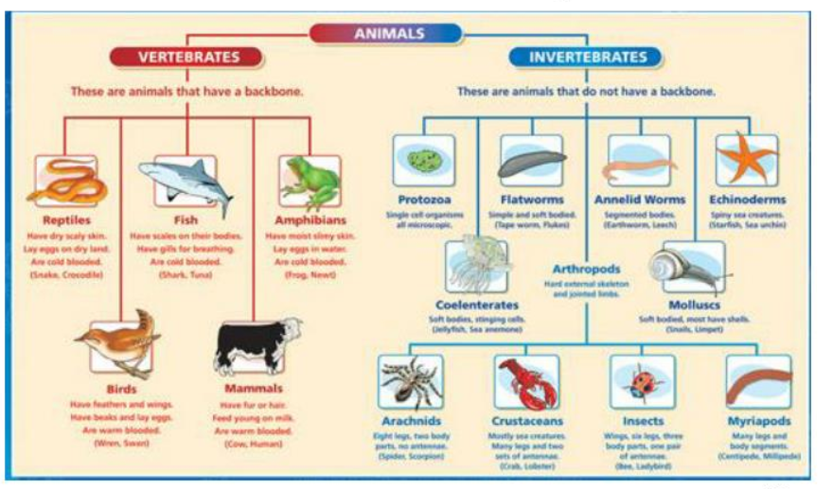
Can you create something similar based on your Year 5 knowledge?

P4C Question: What would a society without British Values look like? How would it feel?

