
Weston Federation of Schools
Designated Safeguarding Lead is Nicki Windle
Contact on 02380448962
n.windle@westonschoolsfederation.co.uk

Key Reminders: To ensure the safety of all on site-
- Bikes and scooters are not to be ridden on the school site at drop off and pick up.
- Ball games are not to be played before or after school on site.
Hello and welcome to our monthly safeguarding newsletter / update.
If there is any aspect of safeguarding and staying safe you would like us to share please let one of the team know.

Road Safety



Children are never too young to start learning about how to cross the road safely, how they should walk on the pavement and how to behave safely near the road and around traffic. They are more likely to learn when out on the road, rather than in a classroom or through talking about road safety at home.

You may think that crossing the road is easy, but for a child it is much more difficult. This is because crossing the road involves many tasks- identifying a safe place to cross the road whilst considering parked cars, junctions, and kerbs, paying attention to traffic, looking, and listening and focussing on the need to walk rather than run across the road.

Therefore, it is a good idea to take your child out near a quiet road to begin to practice crossing the road safely.
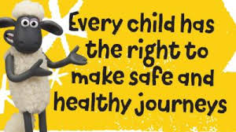

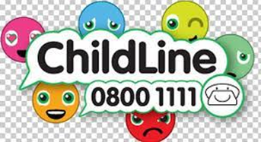

What should I be teaching my child about safely crossing the road?
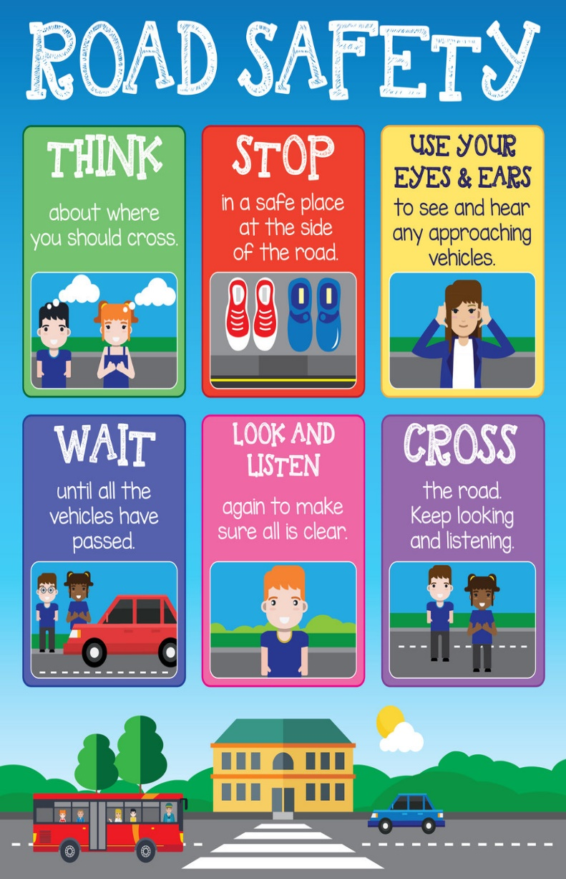

Road Safety

There are clear guidelines about how to keep children safe when travelling in a car or other vehicle.

- A child up to the age of at least 12 or them being 135cm tall is required to be in a car seat / booster seat.
- ALL children regardless of height age or weight MUST wear a seat belt or restraint and be sat in their own seat / space in the vehicle.
- Parents / carers can choose a car seat for their child based on height or weight.
- Height-based – these are rear facing and typically can be used until a child is approximately 15 months old – at this point they need to move to a forward-facing seat.
- Weight-based – the seat used by your child, fully restrained in it can be selected by the weight of your child – as follows

Group Seats

0kg to 10kg 0 Lie-flat or ‘lateral’ baby carrier, rear-facing baby carrier, or rear-facing baby seat using a harness

0kg to 13kg 0+ Rear-facing baby carrier or rear-facing baby seat using a harness

9kg to 18kg 1 Rear- or forward-facing baby seat using a harness or safety shield

15kg to 25kg 2 Rear- or forward-facing child car seat (high-backed booster seat or booster cushion) using a seat belt, harness or safety shield

22kg to 36kg 3 Rear- or forward-facing child car seat (high-backed booster seat or booster cushion) using a seat belt, harness or safety shield.

NB: Manufacturers can now only make booster cushions approved as group 3. This won’t affect any existing booster cushions in group 2 and you’ll still be able to use them.

Important

The above is law – it is a legal requirement to ensure your child or any child in your vehicle is safe. It is also important to keep them safe.

Currently there is a fixed penalty fine of £60 and three penalty points for not using the right child restraint. If the case goes to court, this could increase to a maximum fine of £500 for any occupant anywhere in the car. There would be other charges should the child be harmed as a result of incorrect or lack of restraints.

Riding bikes and using scooters

Lots of children use bikes and scooters to travel to and from school – this is great for their fitness and enjoyment, but we need to ensure they are safe with this.

Avoid baggy clothing that could get tangled up with the scooter or the bike. Children should wear sensible shoes, such as school shoes or trainers (not sandals or flip flops), bright coloured clothing – and of course, they should always have a helmet on – and if needed other protection such as knee and elbow pads.

A helmet is essential when using a bike or scooter and dramatically reduces the risk of a serious head injury should they fall off or an accident occurs.

The same rules apply for crossing a road as if they were walking as a pedestrian – children should not ride bikes or scooters on the road until they have had proper training such as Bikeability.

