

Year R

Pupil Induction

Booklet September

2026
-
2027

Dear Parent/Carer,
A very warm welcome to Weston Park Primary School. We are delighted that your child will be joining our Reception class.
Starting school is an exciting and important milestone, and we are here to support both you and your child every step of the way.
This booklet is designed to provide you with clear and helpful information to ensure a smooth and positive start.
This is how we sum up our school: Creating Endless Opportunities.
We have core values that everyone understands.

- Be safe
- Be responsible
- Be respectful
- Be a learner

Our curriculum reflects our ambition that every child is able to make safe choices and develops a deep spiritual, moral, social and cultural understanding.
We look forward to working with you to help you child achieve their potential.

Yours sincerely,

Weston Park Primary School team

Our leadership team

Mr Wiltshire
Executive Headteacher

Miss Windle Mrs Bulpett
Assistant Head Business Manager
SENDCO / DSL


Mrs Juttla Mr Osborne Mr Rogers
Assistant Head Assistant Head Assistant Head
Weston Shore / DSL KS2 / DSL EYFS / KS1 / DSL

Who to contact
If you have any questions or concerns:
- Class Teacher – your first point of contact (available after school)
- School Office – to arrange meetings or call-backs
- Year Leader or Assistant Head – if further support is needed Email: wpinfo@westonschoolsfederation.co.uk
Safeguarding is a priority for us at Weston Schools federation if you have any safeguarding concerns, please speak to a member of SLT immediately. The leadership team are all trained as designated safeguarding officers (DSL)

Your child’s Learning Environment
Your child will learn and play in a range of welcoming spaces
The burrow

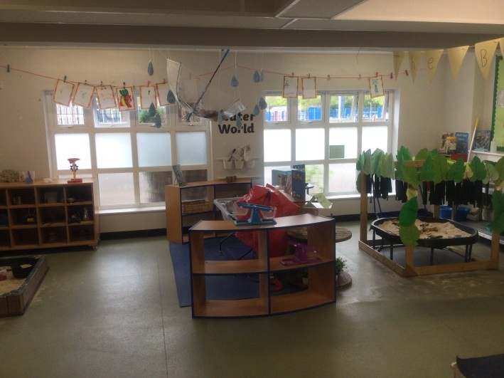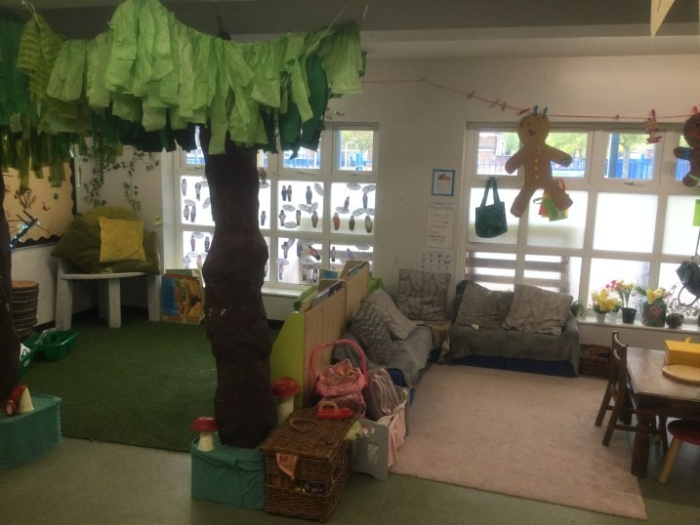
The den The snug
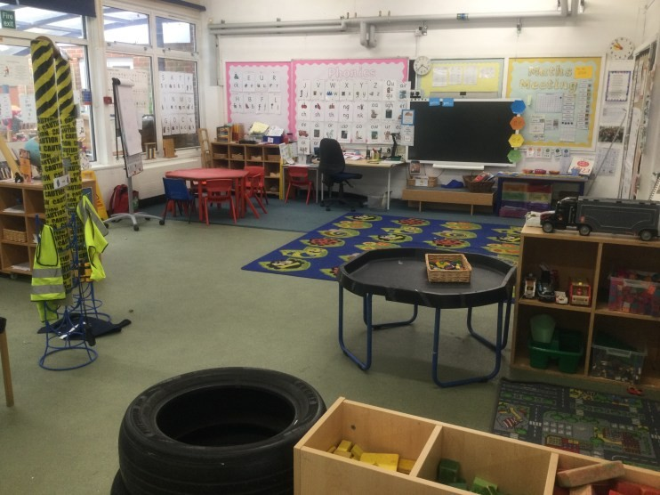
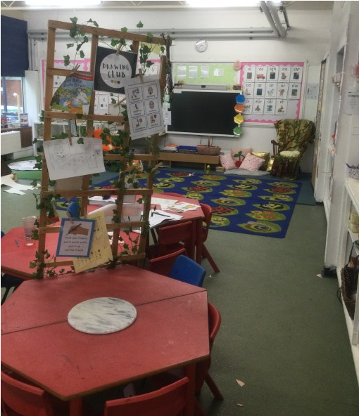

The garden
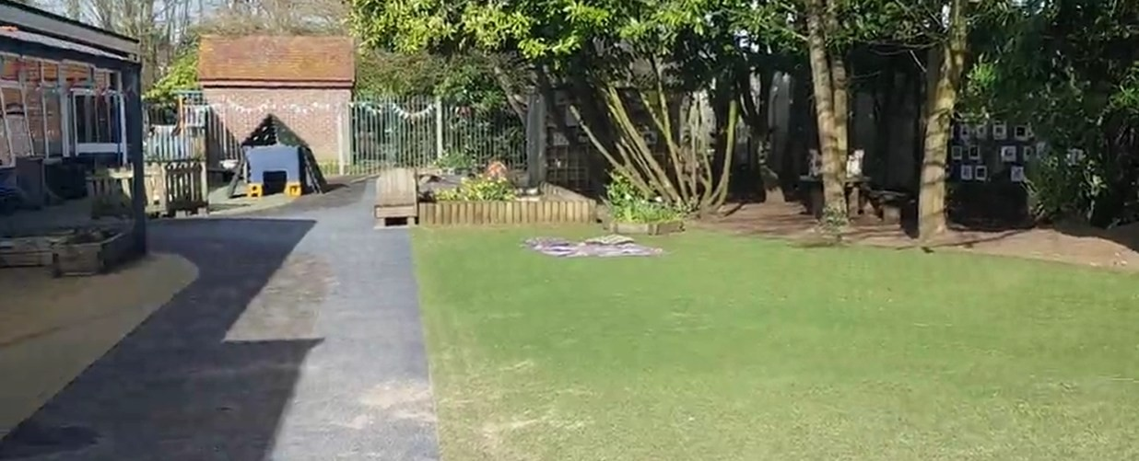

The school day
We operate a soft start to support a calm and positive beginning to the day.
Morning:
Doors open: 8:40am
- Registration: 8:55am
- Late mark after: 9:00am
- Unauthorised absence after: 9:15am

End of Day:
School finishes: 3:15pm
We believe that for a child to reach their full educational achievement a high level of school attendance is essential. We are committed to providing a high-quality education for all our pupils in an environment where all pupils feel valued and welcome. There is an expectation that children attend school on time every day.

Drop-Off and Collection

First Day:
- Bring your child to the Year R entrance, where staff will greet you.

After the First Day:
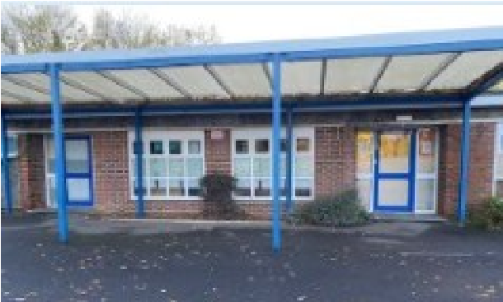
- Drop-off and collection will take place at the Year R entrance. (map included in this pack)

School lunches

All Reception children are entitled to a free school meal.
- Meals are freshly prepared onsite
- A menu will be provided to help your child choose

Alternatively:
Children may bring a healthy packed lunch Lunches must be:
- Nut-free
- Free from sweets and fizzy drinks

Lunchtime: 12:00pm – 12:45pm
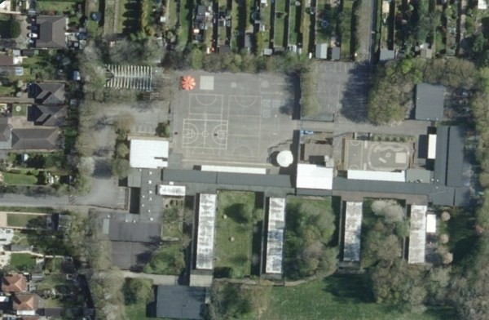

Newtown Rd entrance

Weston Lane
entrance

Chamberlayne field

side gate entrance

Yr. 4 doors

Yr. 3 & 5 door

Yr. 5 & 6 door

Yr. 2 door

Yr. 1 door

Yr. R door

KS1 office

KS2 office

Weston Park Primary School

Uniform at our School
Our aim is that uniform is inclusive and low cost. It consists of the following items
- Black tailored trousers Or Black knee length skirt/pinafore or Black tailored trousers (no leggings)
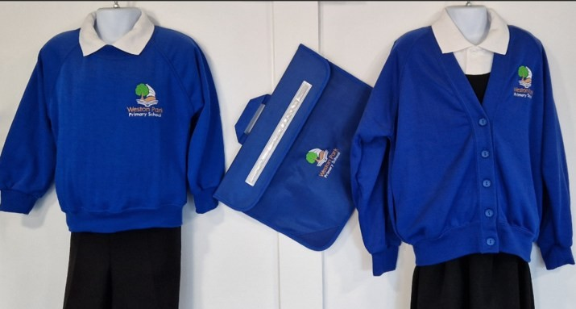
- Royal blue sweatshirt or cardigan with/without school logo
- White collared polo shirt or white shirt
- Black school shoes (no trainers, no heels, no flipflops)
- Black / white socks / Black tights (where applicable)
- During the winter months all children should wear a coat

Purchasing uniform

School sweatshirts, cardigans, polo shirts & coats with the school logo on are available direct from the following uniform suppliers:

Wearabouts at their shop in Woolston or online at wearabouts.co.uk
My Clothing online at myclothing.com.

Pre-loved uniform
We ask all parents to donate any uniform that is still in good condition but is no longer used. Sales of second hand uniform are held from time to time - details of any sales will be advertised on the school website, My Child at School app and the schools Facebook page.

PE Kits
All children are required to have a PE uniform which consists of
- White plain T-Shirt
- Black shorts / tracksuit trousers or leggings
- Black / white plimsolls or trainers

PE kits must stay in school Monday to Friday as PE times can vary.

Please ensure all uniform is NAMED

Communication with Parents

We use MCAS (My Child At School) app to keep you informed.
Through MCAS, you will receive:
- School updates
- Messages and reminders
- Important information
You will be sent login details before your child starts.
Parents’ Evenings:
- Held three times a year Reports:
A written report is shared at the end of the year

Milk and Snacks
Milk:
- Free for children under 5
- Provided by Cool Milk
- Paid option available after age 5 (parents to contact coolmilk.com direct)
Snacks:
- Children receive a free fruit or vegetable snack daily
- You may also provide a healthy snack
- Please provide a labelled water bottle each day
- If Your Child Is Unwell If your child is unwell:
Call: 02380 448 962 (select Option 1)
Please leave a message before the school day begins.
Include:
- Your child’s name and class
- Reason for absence

If your child becomes unwell at school:
- We will contact you

More information to support you can be found here: https://what0-18.nhs.uk/national/worried-your-childunwell/child-unwell-ok-go-nurseryschool . Attached is also a helpful poster.

After School Clubs

A range of clubs are available throughout the year internally and via Superstar Sports directly
Please contact the school office for:
- Current clubs available and availability
- Age suitability

Breakfast club
Weston Park Breakfast Club runs from 8.00am until the start of the school day at 8.40am. Sessions need to be pre-booked.
Sessions cost £4.00 per child (£3.00 for a sibling). A variety of breakfast is provided.
For more information contact the school office
023 80448962 or email wpinfo@westonschoolsfederation.co.uk

Home Learning
Home learning supports your child’s development.

- Expectations are outlined on the school website
- Activities are shared each half term
- We use the Boom reader app to log home reading

- We use the Numbots app to develop maths skills
- Logins will be provided once the children have settled into school

Behaviour and Rewards

We promote a positive behaviour approach based on our core values.
Children can receive:
- Green and gold Stickers
- Blue and pink Postcards
- Pupil of the week awards

Achievements are celebrated in assemblies.

Starting School

We understand that starting school is a big step for both children and parents.
Stay and Play Session:
- Help children become familiar with the environment
- Build confidence before starting

Home visits/ teacher meetings

- We will arrange a home visit or an appointment at school to meet your teacher

First Days:
- Staff will support children as they settle
- Children are encouraged to become independent

Children usually settle quickly, and we will always contact you if needed.

Helping Your Child Prepare
You can support your child by encouraging independence in:
- Dressing themselves
- Using the toilet independently
- Washing hands
- Sharing and taking turns
- Speaking and listening to others

These small skills make a big difference in helping children feel confident and secure.

Final Message

We are excited to welcome your child to Weston Park Primary School.
By working together, we can ensure that your child has a happy, confident and successful start to their school journey.
For further information about how to prepare for starting school please see the attached poster.

