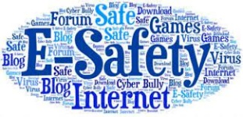

Weston Schools Federation
Designated Safeguarding Lead is Nicki Windle
Contact on 02380448962
n.windle@westonschoolsfederation.co.uk

Key Reminders:
PE kits – please send kit in with your children on a Monday, these can remain at school in their locker and come home on Friday. Thank you
Hello and welcome to our monthly safeguarding newsletter / update.
If there is any aspect of safeguarding and staying safe you would like us to share please let one of the team know.

Online Safety
We are seeing our children and young people spending more and more time online. The raft of apps and games that they have available is vast and ever changing. Here we provide a summary of some of the most popular ones – detailing the risks and guidance associated with them as well as general guidance about social networking.
Please look at the following link for more detail about ALL apps and games –
https://nationalonlinesafety.com/guides
Other useful internet safety advice sites are
www.net-aware.org,uk
www.internetmatters.org
www.thinkyouknow.co.uk

What age can my child start social networking?
As a parent/carer it’s important you know that all social networking platforms (apps) have age limits. Some social networks use technologies that mightn’t be right for some ages, or engage with communities that are made up of people much older than your child.

What are the risks of an underage social networking account?
• Many sites include an instant message function which allows private conversations
• Most social networking sites have an app version, meaning your child will have access to the social network from their smartphone/tablet. Some app versions of social networks use the location of the phone.

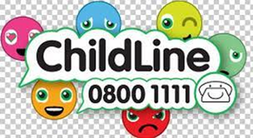

• Information shared between friends can be easily copied and may spread
• It isn’t easy to take back information that has been posted – and can be impossible if it’s already been shared.
• Not everyone your child meets online will be who they say they are. Chatrooms and forums can connect
people who are complete strangers and can be unmoderated
• Chatrooms and forums are one of the places online groomers go to connect with children. They can also be
places where people use a lot of sexual language and engage in online flirting. This is sometimes done through video chat programs.

What are the risks? Should I be worried?
YouTube (along with other social media platforms) should NOT be used by those under the age of 14 due the associated risks of comments on the videos they post and feedback from viewers which may not always be positive or appropriate.
Often what they choose to view or engage with may then lead to less appropriate content being shared with them.
As with all social media platforms, remind children that what they post online might stay around for a long time and be hard to remove and to bear in mind that embarrassing or controversial content might cause unnecessary stress or impact on education or job opportunities later in life.

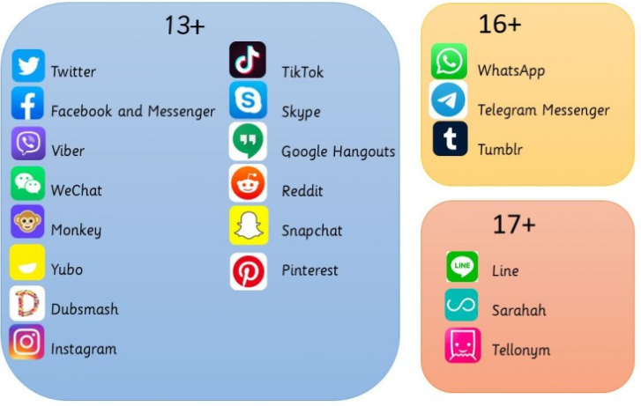

Here to help
Whislt much of the hildren’s activity online, especially on apps happens outside of school we are always seeking ways to help support you and your chldren with this.
On our school websites, under the safeguarding section there are links to report onlne safety concerns and furhter advice too.
Safeguarding - Weston Park Primary School
Safeguarding - Weston Shore Infants School
Here you will find ways to report concerns – sich as
- A direct link to CEOP for reporting exploitation and safeguarding concerns
- A link to the NSPCC for adice and ways to report concerns

There are further links to guidance related to keeping your child safe whilst online and other helpful safeguarding information for parents/carers -
- Keeping Children Safe Online
- Children’s Mental Health
- Child Exploitation and Online Protection – Report to CEOP
- Childline/IWF Report Remove
- Report Harmful Content – Help to remove harmful content

- Report Online Child Sexual Abuse Imagery or ‘Child Pornography’

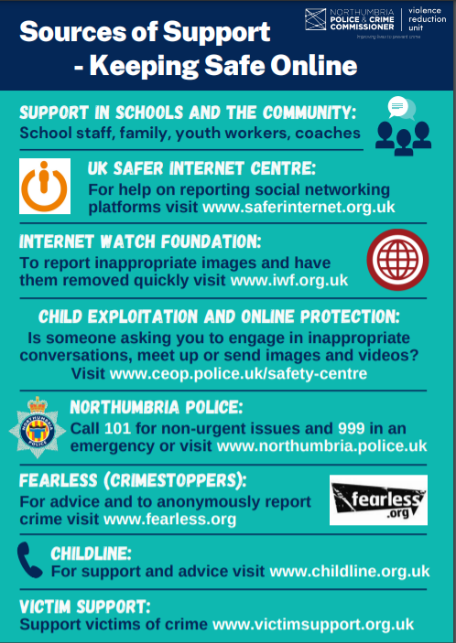


We also have availabe our ONLINE SAFETY HUB.
Here you will find a one stop shop to help understand the risks online and how to keep our young people safe.

Online Safety Hub - Hamwic Education Trust

Please do take a look – there is so much support available.

