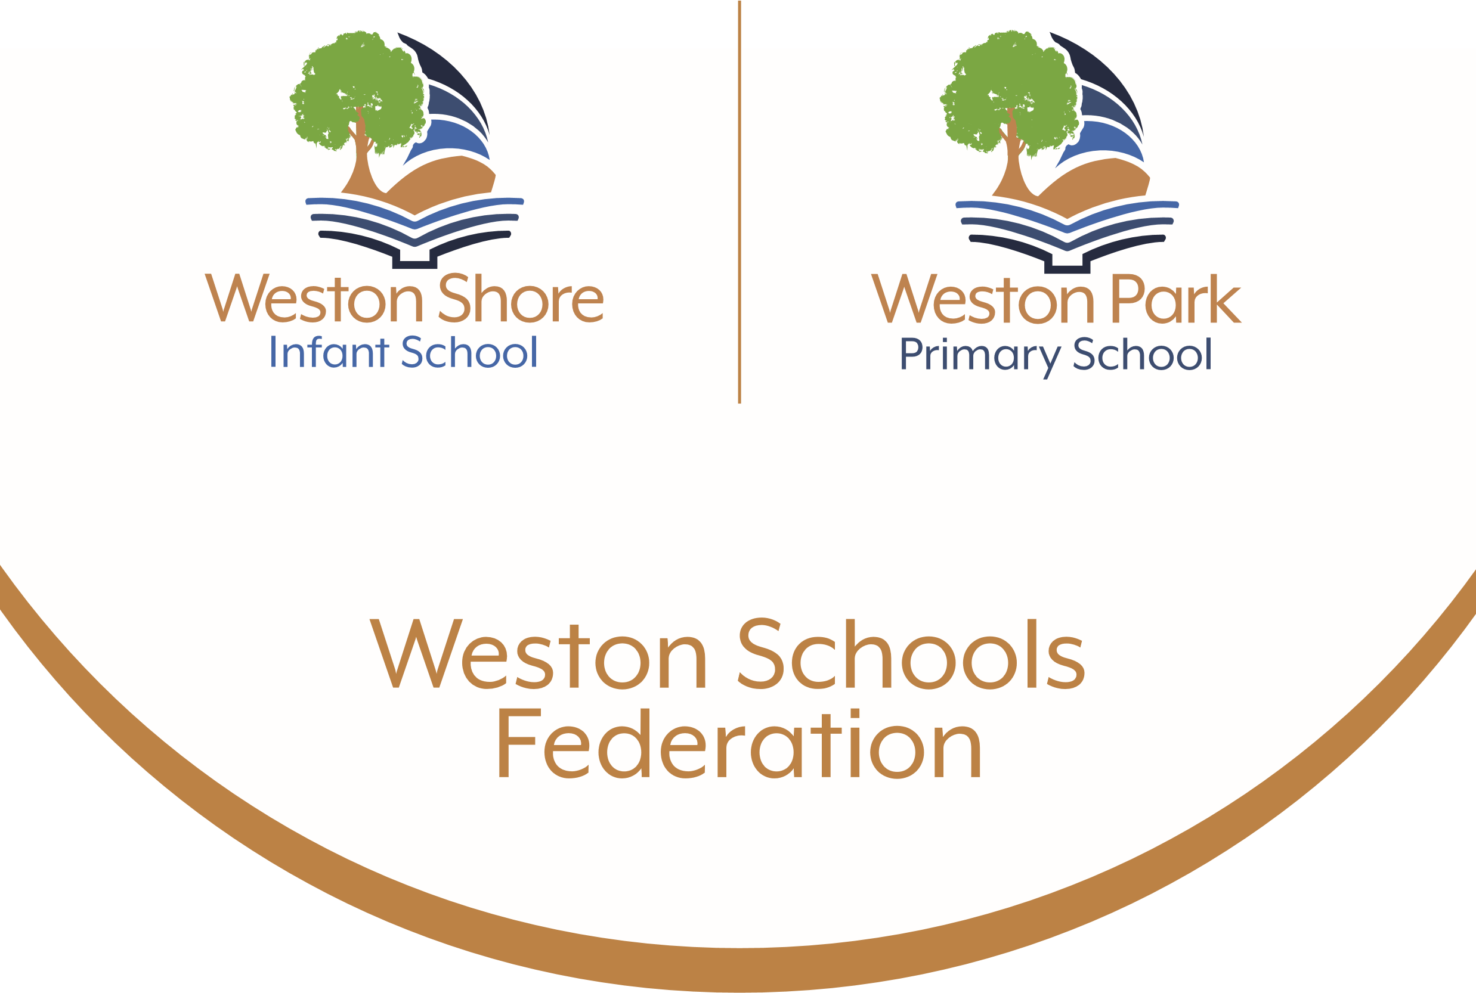

English Policy
2026-2027

The nature of English at Weston Park Primary School and Weston Shore Infant School
At Weston Park Primary School and Weston Shore Infant School, we strongly believe that ‘there can be no more important subject than English in the school curriculum. English is a pre-eminent world language, it is at the heart of our culture and it is the language medium in which most of our pupils think and communicate. Literacy skills are also crucial to pupils learning in other subjects across the curriculum.’ Ofsted, April 2013
We aspire to ensure that our English curriculum is of the highest quality and teaches ‘pupils to speak and write fluently so that they can communicate their ideas and emotions to others and through their reading and listening, others can communicate with them. Through reading in particular, pupils have a chance to develop culturally, emotionally, intellectually, socially and spiritually.’ The National Curriculum, 2014
The English Curriculum
The National Curriculum 2014 sets out the programmes of study for each year group. ‘It is essential that, by the end of their primary education, all pupils are able to read fluently, and with confidence, in any subject in their forthcoming secondary education.’ National Curriculum, 2014
Our school will ensure that in reading lessons, children’s knowledge and experiences are deepened through the use of high quality texts, and in writing lessons, opportunities are provided for children to apply skills and produce outcomes for different audiences and purposes. We endeavour to broaden and deepen a child’s knowledge and understanding rather than pushing higher achievers on to the next year group’s objectives.
Our planning, at Weston Park Primary School and Weston Shore Infant School, is supported – but not dictated by – schemes of work from The Literacy Shed, The Literacy Tree, The Centre of Literacy in Primary (CLPE) and Deepening understanding. Teachers use and adapt schemes of work to match their key texts, the programmes of study for each year group and most importantly the needs of the child.
Units of work for each year group, found within the whole school curriculum overviews, are designed to support cross-curricular learning and provide meaningful opportunities to demonstrate National Curriculum skills. They are purposefully placed within each half term and week to strengthen links between subjects and to broaden knowledge.
English provision at Weston Park Primary School and Weston Shore Infant School
Planning for reading and writing follows the National Curriculum Programmes of Study for each year group and should outline the intended learning journey.

Reading provision

The programmes of study for reading at key stages 1 and 2 consist of two dimensions:

♣ word reading
♣ comprehension (both listening and reading).

At Weston Park Primary School and Weston Shore Infant School, teaching focuses on developing pupils’ competence in both areas. In Key stage 1, reading lessons are predominantly weighted towards decoding and skilled word reading. Children learn how to read through discrete phonics lessons and through reading Little Wandle reading practice sessions.

At Weston Park Primary School and Weston Shore Infant School, we expect children to be fluent readers at the end of Key Stage 1 in order to access learning in other curriculum areas, experience higher level texts, and broaden their knowledge of the wider world. In order to do this, we follow the Little Wandle programme for phonics and fluency. For further guidance, please refer to our Phonics policy.
During Key Stage 2, the weighting of taught reading shifts towards developing reading fluency and comprehension. Reading fluency and comprehension skills are taught as a whole class model, providing children with the opportunity to experience high-quality discussion with the teacher, as well as from exploring and discussing a range of stories, poems and non-fiction.

Teachers across both Key Stages will refer to ‘Reading vipers’ when planning, teaching and questioning in comprehension lessons. Using VIPERS for reading ensures that children become proficient across all the National Curriculum reading domains.

VIPERS:
- Vocabulary
- Infer
- Predict
- Explain
- Retrieve
- Summarise

Reading stems are provided to support oracy and the rich discussion around a text alongside high level justification of a child’s viewpoint. Each phase – KS1, Lower KS2 and upper KS2, uses a progressive set of stem sentences, which are displayed on the reading working wall alongside key vocabulary in classrooms.

Please refer to appendix 1 for a detailed reading provision from Year R to Year 6.
Reading aloud
All children are heard reading aloud, by the teacher, on a 1:1 basis at least once every two weeks, however some children, according to their individual need, are heard more frequently. In addition to the minimum requirement provided by the class teacher above, the following is provided:
- EHCP children. These children are heard daily by their 1:1 adult.
- PA/absent children - These children are heard upon their return to school.
- Lower attaining readers (decoding and sight recognition) – Reading interventions such as Little Wandle Rapid Catch up are delivered daily by a teaching assistant.

Reading at home

All pupils are encouraged to read widely across both fiction and non-fiction to develop knowledge of themselves and the world in which they live, to establish an appreciation and love of reading, and to gain knowledge across the curriculum. It is expected that children read both in school and at home.

Daily reads are recorded on an online reading record called Boom Reader. Home reading is rewarded through a series of reading badges presented in celebration assembly each week.
KS1 reading award |  | KS2 reading award
Award | Number of reads | Award | Number of reads
Yellow star | 10 | Yellow star | 20
Green star | 20 | Green star | 40
Red star | 40 | Red star | 60
Blue star | 60 | Blue star | 80
Silver star | 80 | Silver star | 100
Gold star | 100 | Gold star | 125
Star reader | 150 | Star reader | 150
Bronze book worm | 200 | Bronze book worm | 200
Silver book worm | 250 | Silver book worm | 250
Gold book worm | 300 | Gold book worm | 300

Each child has access to a variety of books. At school and at home, children have access to a Little Wandle or age-appropriate text, which they can read fluently and independently. Children are also able to select a love of reading book from the library or book corner to read at home or at school.
Parents are expected to hear their child read 5 times per week and to record this on Boom Reader.
Closing the gap in reading
For those children who require it, teaching staff provide reading and phonics interventions to support individual progress. Those children who do not have opportunity to read often at home will be supported further in school with additional provision.
The interventions in school are:
- Little Wandle Daily Keep Up
- Little Wandle Rapid Catch Up
- Little Wandle Fluency Programme
- HfL reading fluency project – KS1 and KS2
Common exception words
Common exception words for each phase are listed in the National Curriculum programme of study. The reading of these words is tracked for each child termly. Records are kept in the class reading file. If a child is able to read the word, it is highlighted.
- Autumn term – green
- Spring term – pink
- Summer term – yellow
The spelling of these words is also tracked termly. Common exception words are linked in to writing units where possible.

Promoting the Love of reading
Each class has the opportunity to visit the library each week. Slots are 30 minutes per class.
Every class enjoys a ‘class reading book’ together. This is shared daily with the children. Year groups compile a scrap book to showcase the books they have enjoyed together during this time. The cover of the book will be added to the scrap book, the learning that has taken place alongside and comments from the children. Quite often these comments are personal thoughts or answers to questions set by the teacher.
Writing provision
The programmes of study for writing at key stages 1 and 2 are constructed similarly to those for reading:
♣ transcription (spelling and handwriting)
♣ composition (articulating ideas and structuring them in speech and writing).

It is essential that teaching develops pupils’ competence in these two areas, alongside how to plan, revise and evaluate their writing. Each unit of writing should follow the agreed ‘reading into writing’ model across the school, showing a clear independent outcome. Learning will be progressive and ensure the children are taught the skills, knowledge and understanding needed to complete the independent outcome and evidence good progress within and between units of work.
Reading into writing
At Weston Park Primary School and Weston Shore Infant School we follow a ‘reading into writing’ model to teach writing. Teachers begin this journey by mapping ‘text potential’ prior to planning a unit of work. This ensures that the chosen text is fit for purpose, is of high quality and the teaching of vocabulary can be planned for.
Purpose, audience and form are key drivers in each unit of writing. These are shared with the children at the start of a unit and can been seen on the working wall and unit cover sheets within children’s exercise books.
The principles of the reading into writing model are:
- Text immersion
- Skills building
- Teacher modelling
- Independent application

Text immersion stage -
During this stage, tier 2 and 3 vocabulary from the text must be discussed and displayed.
- Commonly used words form Tier 1 vocabulary.
- Tier 2 vocabulary develops words that do not form part of a child’s everyday language but are relatively common place and can be used between different contexts.
- Tier 3 vocabulary contains words that are highly specific and topic based.
A ‘WAGOLL’ should be used to demonstrate ‘What A Good One Looks Like.’ This WAGOLL must contain exemplification of the key skills to be taught in the unit. This becomes a writer’s ‘toolkit.’
At Weston Park Primary School and Weston Shore Infant School, we explore text or film stimuli, at the start of a unit, in a variety of ways: book talks, drama techniques, debates and text discussions are a few examples. This stage of writing is heavily discussion based. There would be little written work from the children so exercise books may only show photo pages to evidence this stage. The working walls in classrooms are showcases for rich vocabulary that has been ‘magpied’ from various sources.

Skills building stage –
This is a heavily guided, taught and marked stage in the reading in to writing journey. Key unit skills are broken down for children. This is a practise stage whereby teachers would use ‘I do/you do’ sessions, sentence doctor workshops or skills building sessions to teach National Curriculum objectives from the appropriate programme of study. Children would be writing sentences or short burst paragraphs only in their books to practice and master this skill. The English working wall would be used to gather examples and provided support for this stage of writing.
Teacher modelling stage –
This is another heavily guided, taught and marked stage in the reading into writing journey. In lessons, teachers model writing sentences, paragraphs or whole texts to the children, verbalising explicitly the choices they are making as writers, alongside their reasoning. Sometimes children will listen, sometimes they may join in verbally or with whiteboards.
It is important that outcomes from any skills sessions, short burst writes or teacher models be different to the independent outcome expected by the children.
In each of the taught phases above, children are supported with a clear learning objective (WALT) and steps to success or success criteria that help the child to unpick the learning objective. Please refer to the marking and feedback policy for further guidance.
Independent application stage –
Independent writes will be easily identified in children’s books. Each independent piece will start with a yellow context card stating the audience, purpose and form. There will be no success criteria/WALT sticker in books for an independent write.
Independent writes are completed on the left hand page of a double page spread. The right hand page is used for editing in green pen. At Weston Park Primary School and Weston Shore Infant School, editing is far more than correcting spelling or punctuation. Children need to develop the ability to select paragraphs or sentences re-drafting. The school teaches editing as part of the writing process. Children use ‘editing stations’ alongside a peer to edit in a supported manner. Children should always be mindful of the purpose and audience of pieces and choose vocabulary and structures accordingly. There will be less teacher marking for independent writes. Open ended advice should be given at this point rather than specifics.
Short term planning
Writing planning should not be over detailed, however should indicate the following:
- a clear independent outcome
- clear purpose, audience and form for the piece of work
- National Curriculum taught skills
- a progressive ‘reading into writing’ teaching sequence
- vocabulary that is expected
- differentiation
- links to spelling rules, common exception words, handwriting and phonics.
Teachers within each team should discuss the planning, teaching and assessing of English together. The planned teaching sequence must link to a high quality stimulus – a quality text or film clip; have a series of inputs to teach the children new skills; it must have opportunities for teacher modelling and for children to practise; it must be rich in vocabulary and supported by discussion and images to aid a child’s understanding. These key elements of the teaching sequence must be displayed on the English working wall to support independence.
Spelling
In Key Stage 1, children move from Little Wandle phonics provision on to the Little Wandle ‘bridge to spelling’ programme. This can be seen in appendix 3 and 4 of this policy. This programme revisits phase 5 phonics, then makes the bridge to spelling.
In Key Stage 2, spelling Rules are taught according to the programme of study in the National curriculum.
Children are expected to read and write the common exception words linked to their year group. These words are taught and used within writing lessons. Each unit has specific common exception words and ‘spelling rule’ words linked to it.
Children’s progress in spelling these common exception words is recorded on a termly tracker. There are common exception word lists for year groups and phases, as per the National Curriculum appendix 2.
Handwriting
At Weston Park Primary School and Weston Shore Infant School, we follow the Weston Schools Federation handwriting policy. It is expected that children are able to write fluently and legibly with correct joins at the end of year 4. Handwriting is not taught explicitly in year 5 and 6; interventions are used to support children in these year groups where necessary.
Presentation in English
Children at Weston Park Primary School and Weston Shore Infant School are taught how to present their work to a high standard and encouraged to take a pride in their work in line with current school guidelines. The children write and underline the long date at the start of each new session. Pencil shall be used in the first instance. Where handwriting meets expected standards, a child will be awarded a pen. Members of SLT make the final decision as to whether pens are used to write with.
For further guidance please view the Handwriting policy.
Please refer to appendix 2 for a detailed writing provision from Year R to Year 6.
Marking and feedback in English
Pupils learning should always be marked in accordance with the ‘Marking and Feedback Policy’. Teachers will check pupils’ understanding and provide clear, direct feedback at the point of teaching by lapping the room in between teaching groups and providing workshops to clarify misconceptions. Where verbal feedback is given in a lesson, this should be marked VF in accordance to the school’s marking and feedback policy. Time must be given for responding to the marking and an expectation is that children will correct errors in green pen before moving on to the next part of their learning.
Tracking and assessment in English.
National curriculum skills for reading and writing are tracked centrally by teachers on DC Pro.
Individual reading is tracked in the class reading file on the appropriate tracking document. This this will depend on phonic phase or reading stage of the child.
At the end of each term, each child will complete a PIRA assessment in reading. In Year 6, this will be a mock SATS reading paper every half term in the build up to the SATS in May. This is to ensure children are familiar with test procedure and give teachers additional evidence to use in their assessment. The results of these will be recorded on DCPro. Independent writes are used to provide assessment evidence and next steps for a child in writing.
Moderating English judgements
As part of the assessment cycle there will be regular opportunities to moderate evidence in workbooks to validate teacher assessments in year groups, across phases and across schools in the trust. Evidence must indicate that:
• children are making progress which is appropriate for their age and ability and that students are sufficiently challenged
• children are able to read and write independently for extended periods of time.
Evidence must be robust, reliable and recent.

